JOB POSTING FOR EXECUTIVE DIRECTOR
Page 1 of 3
FACEBOOK POST


PAGE 2 OF 3
WEBSITE POST

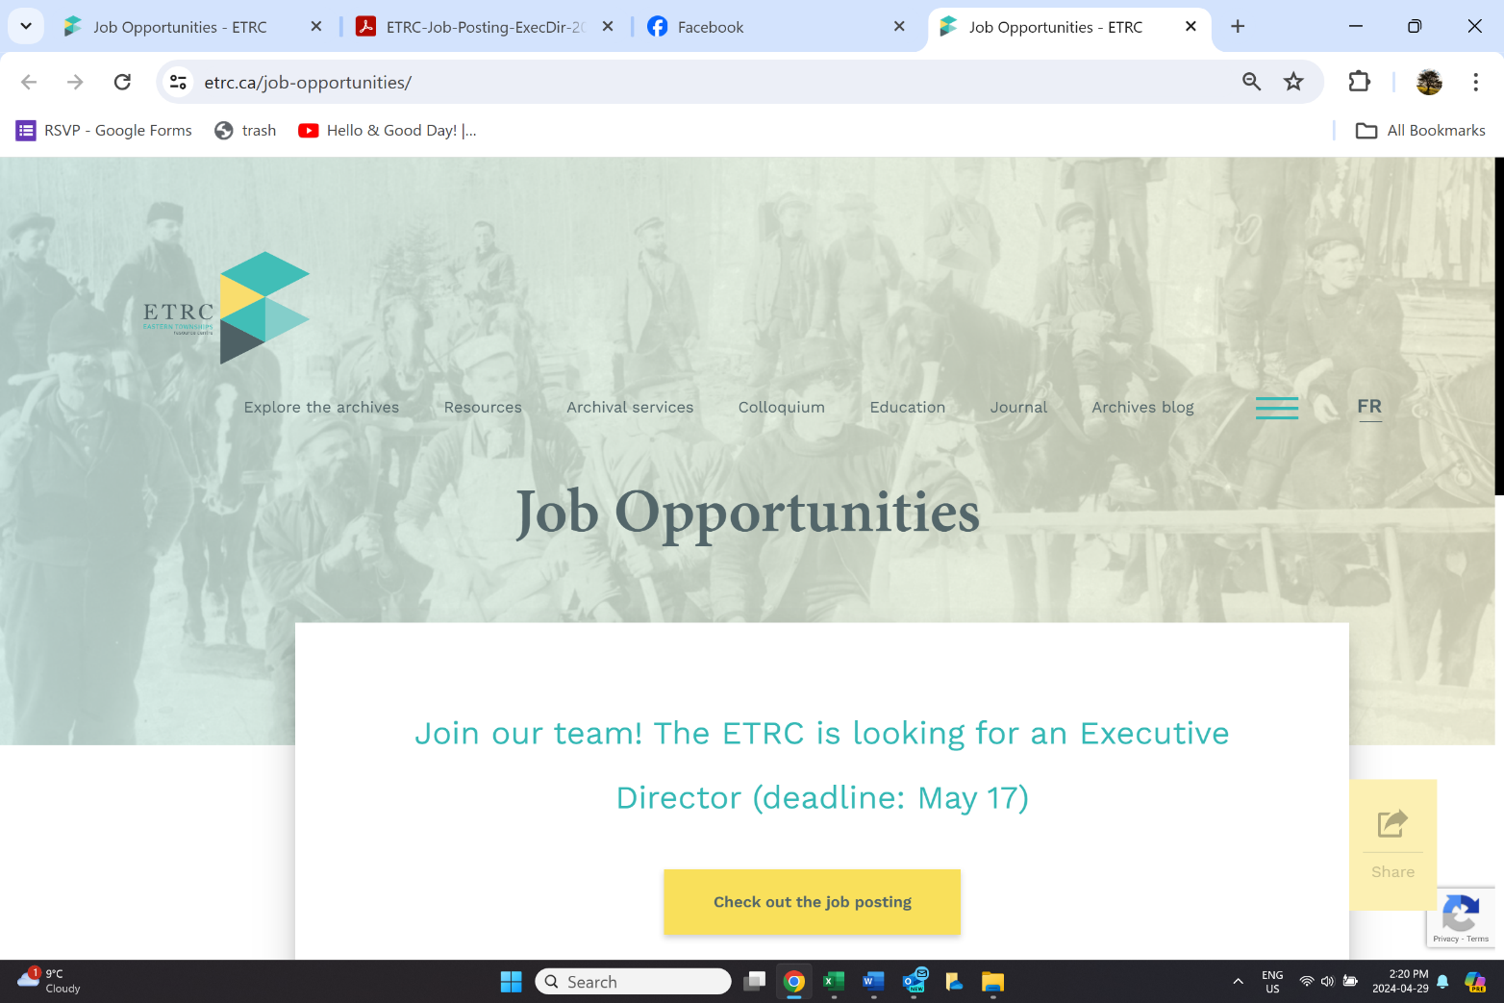

Job Posting next page


Executive Director
Eastern Townships Resource Centre (ETRC)

For 40 years, the ETRC has been a leading center for the study of the Eastern Townships of Quebec. While its archives focus on the acquisition of private archives related to the English-speaking community, the Centre’s mission, mandate, and on-going activities include all communities present in the Eastern Townships. The ETRC preserves the documentary heritage of the Eastern Townships and provides archival expertise and assistance to local heritage organizations. Accredited by Bibliothèque et Archives nationales du Québec, the ETRC acquires, processes, preserves, and gives access to archival fonds and collections that illustrate the development of the Eastern Townships’ English-speaking community.

Description:
Under the responsibility of the Board of Directors, the Executive Director oversees and plans the Centre’s programing, fiscal management, and staff. They design, plan, coordinate, and carry out the organization's administrative activities and budgetary orientations. The Executive Director promotes and ensures the visibility of the institution in the community and seeks funding from public and private agencies to secure the Centre’s sustainability and development. The Executive Director coordinates academic events and projects that feature the dissemination of the Centre’s archival fonds and collections.

General Responsibilities:
- Planning and managing human and financial resources of the Centre within the framework of policies established by the Board;
- Planning and organizing academic events in cooperation with university stakeholders, exhibitions, and outreach activities;
- Maintaining effective relationships with various levels of government, private foundations and Bishop’s University as well as with the local community;
- Representing and promoting the Centre to the heritage community and the media.

Qualifications and Skills Profile Education and experience

- University degree in Museology, History or Archives Studies, or related field; - At least 3-years of recognized experience in management.

Specific knowledge

- Extensive knowledge of the heritage field;
- Successful record in grant applications and project management; - Knowledge of Eastern Townships history;
- Knowledge of current communication trends (print and electronic media); - Bilingual, fluent in French and English, both written and spoken;
- Knowledge of the local, regional, and provincial Anglophone environment; - Knowledge of archives management would be an asset.

Skills and Abilities

- Diplomacy;
- Entrepreneurial spirit;
- Ability to relate to the public;
- Excellent oral and written communication skills;
- Creative and innovative;
- Mobilizing leadership;
- Ability to coordinate different tasks simultaneously;
- Excellent management of deadlines and delivery times;
- Autonomy, availability, dynamism;
- Ability to work in a team and to adapt quickly to changes and unexpected events;
- Ability to represent the ETRC within the Bishop’s community and work harmoniously with faculty, staff, and students.

Conditions of employment:

Full-time position (32.5h/week) at $ 31.97/h (non-University position) Workplace: Bishop’s University campus, Sherbrooke

To apply:
Please forward your cover letter and resume, by May 17, 2024 (5pm), to etrc2@ubishops.ca

Please note that only candidates selected for an interview will be contacted. The ETRC values equal access to employment for women, visible and, ethnic minorities, Aboriginal and disabled people (including the possibility of accommodation during the selection and pre-selection of candidates).

