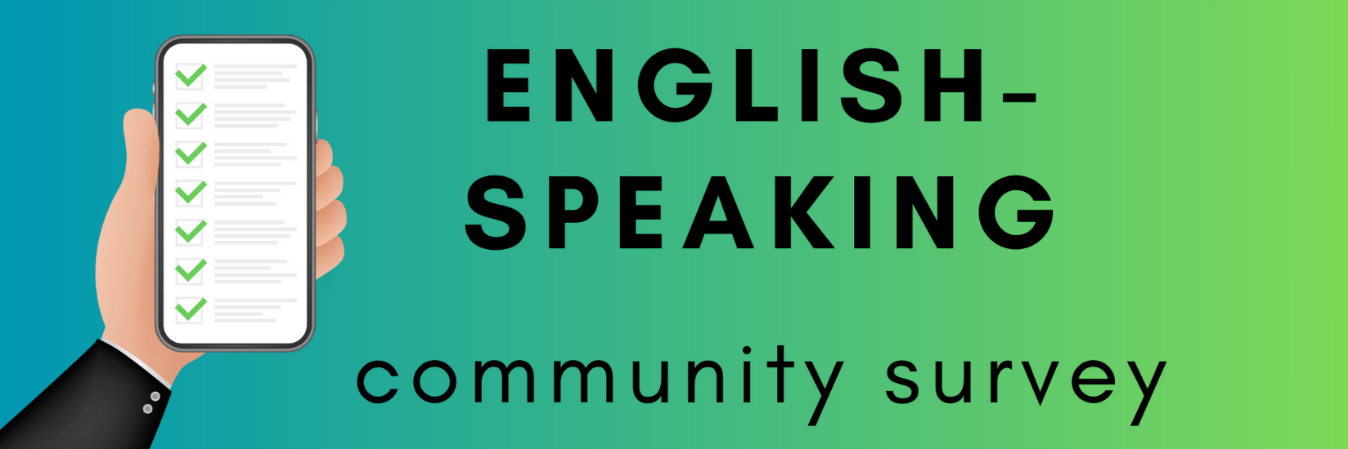

Input from you, members of the region’s English-speaking community, helps guide our organization’s planning for the future. For each question, please choose the option that best describes your answer or opinion. Please answer all the questions. There are 22 questions, and it takes between 5 and 10 minutes to complete the survey.

1. My postal code is:

_____________________________________________________________________________

1. Please choose the age group you belong to:

12 – 17

18 – 35

36 – 59

60 – 79

80+

1. Having access to information about services that I, or someone I know may need in English is

Very important to me

Somewhat important to me

Not at all important to me*

*please explain why:

_____________________________________________________________________________

1. Receiving medical care and other health related services in English is

Very important to me

Somewhat important to me

Not at all important to me*

*please explain why:

_____________________________________________________________________________

1. Having English-speaking community representatives at the local decision-making level is

Very important to me

Somewhat important to me

Not at all important to me*

*please explain why: _____________________________________________________________________________

1. Having English-speaking community representatives at the regional decision-making level is

Very important to me

Somewhat important to me

Not at all important to me*

*please explain why:

_____________________________________________________________________________

1. Having English-speaking community representatives at the provincial decision-making level is

Very important to me

Somewhat important to me

Not at all important to me*

*please explain why:

_____________________________________________________________________________

1. Having access to employment information and support services in English is

Very important to me

Somewhat important to me

Not at all important to me*

*please explain why:

_____________________________________________________________________________

1. Having access to employment opportunities where English is a required skill is

Very important to me

Somewhat important to me

Not at all important to me*

*please explain why:

_____________________________________________________________________________

1. Having access to networking opportunities that put me in direct contact with employers is

Very important to me

Somewhat important to me

Not at all important to me*

*please explain why:

_____________________________________________________________________________

1. I am aware of the English services available in my region

Yes, I am a regular user

I am not a regular user, but yes I know how/where to find services in English

I have limited or no knowledge of how/where to find services in English

I do not use services that are offered by community organizations in English

1. Having an English school board is

Very important to me

Somewhat important to me

Not at all important to me*

*please explain why:

_____________________________________________________________________________

1. It is important to me that community is directly involved in English school boards by (circle all that apply)

Being elected by the wider community to be a board administrator

Having input on curriculum

Participating in a town-hall type event a few times a year to give input to administrators

It is not important to me*

*please explain why:

_____________________________________________________________________________

1. I am a registered member of this organization

Yes

No*

*please tell us why not:

_____________________________________________________________________________

1. I have attended an activity or event hosted by this organization in the last year

Yes

No

1. I have attended an activity or event hosted by this organization in the last 3 years

Yes

No

1. What kind of English language cultural activities would you like to have available in the region? (circle all that apply)

Concerts

Theatre productions

Radio

Podcasts

I would appreciate more bilingual entertainment

I would appreciate entertainment options where language is not important (instrumental music, dance, etc.)

Something else

______________________________________________________________

1. Have you ever visited our website?

Yes

No

1. Do you receive our organization’s newsletter via email?

Yes

No thank you

Please sign me up at this email address: _____________________________________________

1. Please choose the **most important issue** our organization should prioritize in the next 3 years

Access to health and social services in English in the region

Employment opportunities and improving the socio-economic status of English-speakers living in the region

Representing the needs of English speakers in the region to government officials and other decision-makers

Changes to English education

Integration of English-speaking newcomers in the region

Retention of young people in the region

I don’t have an opinion

1. What age group in the region do you think needs the most support from our organization, and why?

0 - 17 ______________________________

18 - 35 ______________________________

36 - 59 ______________________________

60 - 79 ______________________________

80+ ______________________________

I don’t know

1. What is your overall level of appreciation for our organization?

|  |  |  |  |  |  |  |  |  |  |  |
| --- | --- | --- | --- | --- | --- | --- | --- | --- | --- | --- |
| 0 | 1 | 2 | 3 | 4 | 5 | 6 | 7 | 8 | 9 | 10 |

What made you choose that score? __________________________________________________________

____________________________________________________________________________________________________________________________________________________________________________________________

______________________________________________________________________________________________

**Return your completed survey before deadline date one of two ways:**

* As an email attachment to [email@organization.org](mailto:email@organization.org) (filled pdf or scanned printout)
* Mail to Name of Organization, Attention: Partners Survey, Address Line 1, Address Line 2, City, QC, Postal Code