

Reporting

Simplified Action Plan Performance Review

For each objective:
(5 min max per objective)

- Monitoring the progress of planned actions
Are the planned actions progressing as expected?
Overall what is the status of the objective?

- Monitoring the risks associated with our planned actions
Are there new challenges involved in their implementation?
If so, what measures are required to appropriately address the identified risk(s)?
Are the necessary countermeasures in place/in practice?

- Monitoring results (annual indicators, i.e., targeted results)
Do our actions produce their desired results?
Do some of our actions need to be adjusted?

Ad-hoc points throughout the year:
- Review of the entire annual action plan (Bi-annually: July, March)
What is our status vis-à vis the overall objectives?
In case of deviations, what adjustments should be applied?
Are there any new external factors that require us to adjust our plan?

- Review of our long-term performance (organizational mandate/mission)
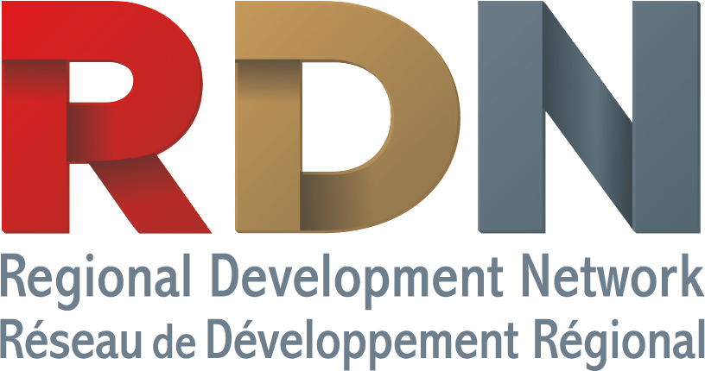
How are we fulfilling our mandate?
Are our current orientations and objectives producing the desired results?

